High Level Design (HLD)

|  |  |
| --- | --- |
| Author | Amrit Bhowmick |
| Version |  |
| Last Revised Date |  |

Amazon Sales Data Analysis

**Contents:**

**Abstract** ......................................................................................................................................3

**1 Introduction** .............................................................................................................................5

1.1 Why this High-Level Design Document? .........................................................................5

1.2 Scope ...............................................................................................................................5

**2 General Description** ................................................................................................................6

2.1 Product Perspective & Problem Statement .....................................................................6

2.2 Tools used........................................................................................................................6

**3 Design Details**.........................................................................................................................7

3.1 Functional Architecture ....................................................................................................7

**4 KPIs**.........................................................................................................................................9

4.1 KPIs (Key Performance Indicators) .................................................................................9

**5 Deployment** ……………………………………………………………………………………………………………….9

Abstract

The Ecommerce Sales Data Analysis High-Level Design Document outlines the plan for analyzing sales data for an ecommerce company, with the goal of providing valuable insights into customer behavior, product performance, and overall business trends. The document presents a high-level overview of the proposed solution, which involves gathering and processing large amounts of data from various sources to create a unified data model for analysis.

The design includes a comprehensive data pipeline architecture that involves data extraction, transformation, and loading (ETL) processes to collect data from various sources such as ecommerce platforms, payment gateways, and customer service databases. The data is then cleansed, transformed, and aggregated to create a unified data model that can be used for analysis.

The document also outlines the various analytical methods that will be used to derive insights from the data. The results of the analysis will be presented through interactive dashboards and reports, which will enable stakeholders to make data-driven decisions.

1. Introduction

1.1. Why this High-Level Design Document?

The purpose of this High-Level Design (HLD) Document is to add the necessary detail to the current project description to represent a suitable model for coding.

This document is also intended to help detect contradictions prior to coding, and can be used as a reference manual for how the modules interact at a high level.

The HLD will:

• Present all of the design aspects and define them in detail.

• Describe the user interface being implemented.

• Describe the hardware and software interfaces.

• Describe the performance requirements.

• Include design features and the architecture of the project.

• List and describe the non-functional attributes like:

o Security

o Reliability

o Maintainability

o Portability

o Reusability

o Application compatibility

o Resource utilization

o Serviceability

1.2. Scope

The HLD documentation presents the structure of the system, such as the database architecture, application architecture (layers), application flow (Navigation), and technology architecture. The HLD uses non-technical to mildly-technical terms which should be understandable to the administrators of the system.

2. General Description

2.1 Product Perspective and Problem Statement

Sales management has gained importance to meet increasing competition and the need for improved methods of distribution to reduce cost and to increase profits. Sales management today is the most important function in a commercial and business enterprise.

2.2 Tools Used

2.2.1. MS Excel

Microsoft excel is used for loading the data in csv format, basic data cleaning and filter operations to execute the program and after that it was used to create visual representations of data.

3. Design Details

3.1 Flow of Data Analysis

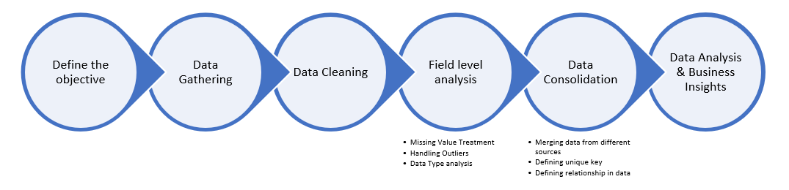

4. KPIs (Key Performance Indicators)

Key indicators displaying a summary of the sales and its relationship with different metrics.

1. Region wise count of orders
2. Region wise total units sold
3. Country wise total revenue
4. Total units sold by each items
5. Region wise total profit
6. Total cost, total profit by order priority
7. Year wise units sold
8. Year wise total revenue
9. Year wise total cost, total revenue, total profit.

5. Deployment

This dataset has been analyzed using excel.